**Skyward – Employee Access Guide**

Please follow the link below to login for the first time (this link is also located on the district homepage):

[**https://skyward.iscorp.com/ElizabethSDCoBus**](https://skyward.iscorp.com/ElizabethSDCoBus)

Once the webpage has loaded, click the bottom button that says “Sign In with ESD Google Account”

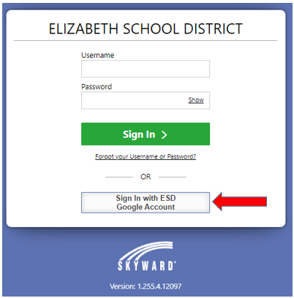

Enter your Elizabeth School District email and click next. On the next screen, enter the same password you enter to access your email and click next:

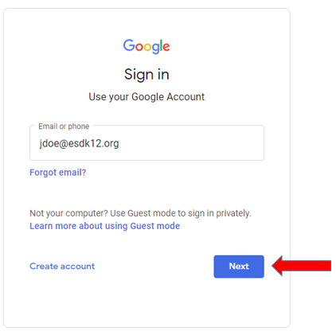 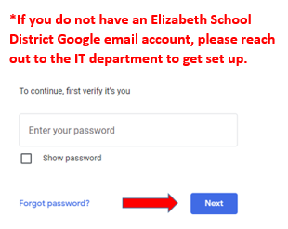

This should now take you to the Home/Employee Access page.

Please Note: If you have administrative duties, you will have to go to the Employee Access page as you have a different landing page.

**Employee Access**

Your Employee Access screen should look something like this:

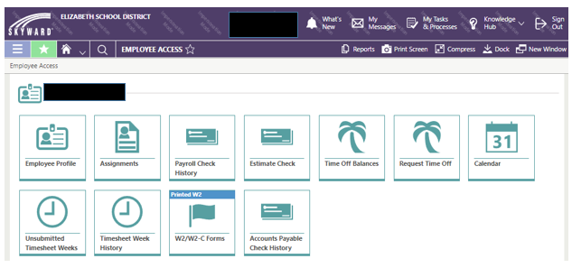

To review your paycheck, click on the “Payroll Check History” tile. Then, click on the downward arrow and select Wage Statement (Employee Access):

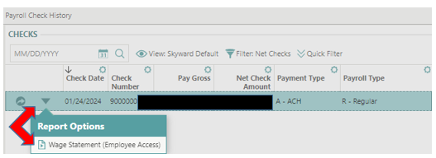

Leave all fields as the default then click Run Report to see your pay stub:

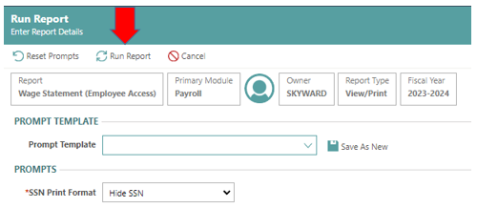

**Checking Your Pay and Taxes**

We have been working hard for the past several months to make sure your information is correct, however, we will rely heavily on each of you to confirm your paychecks.

Please check your paystub under Employee Access in Skyward once paychecks have been issued. Your net pay has changed from December as tax tables change in January every year. Please check to see that your STATE and FEDERAL taxes are being withheld at the amount you need based on your household income.

In addition, many employees have not completed a new W-4 form (for withholding) since the big withholding changes in 2020. Please take this opportunity to update your form and make any necessary changes for the next pay period by completing a new 2024 W-4 withholding form. The current W-4 form can be found [here](https://www.irs.gov/pub/irs-pdf/fw4.pdf). Once completed, submit to Sierra Evans Ardrey in the finance office or by email at [sevansardrey@esdk12.org](mailto:sevansardrey@esdk12.org).

**Tax Documents/W-2s**

All prior year tax documents will be coming from our old system. As a result, they will not be accessible in Skyward until January 2025 for the 2024 tax year. All 2023 W-2s will be sent out to the buildings as they have in past years.

**Employee Expense Reimbursements**

Employees must now enter their own expense reimbursements in Skyward. For example: mileage reimbursements, supply purchases, and/or conference reimbursement. All reimbursements must be submitted no later than 30 days from the date of purchase (or end of month following mileage usage).

To enter your reimbursement request, log into Skyward and under employee access click on the expense reimbursement tile.

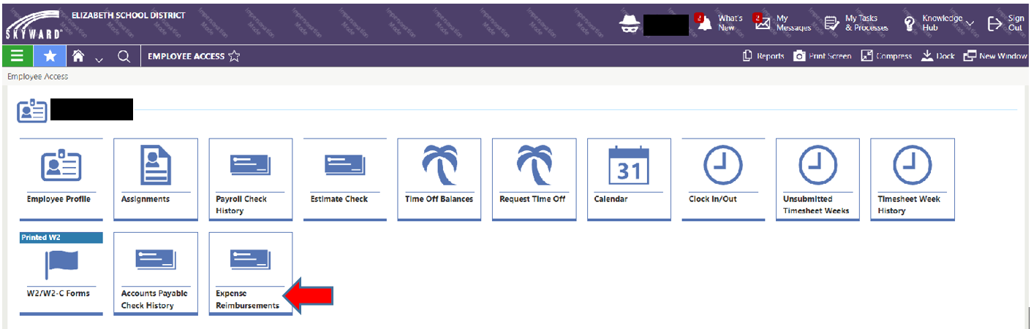

Add expense reimbursement.

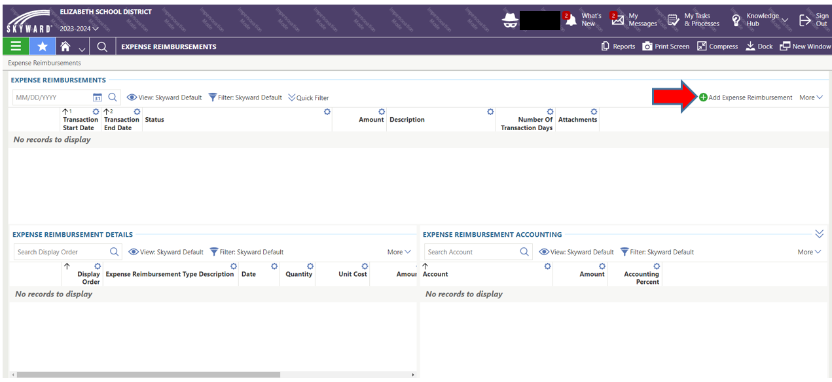

**Note:** If you receive an error stating “You are unable to create an Expense Reimbursement because you are not listed as a Vendor. Please contact your administrative office to get added as a Vendor,” contact Tina Waymire at 1831 to set one up.

All reimbursements must have adequate backup attached. Receipts must be itemized. Transaction start date must match the receipt representing the date of the purchase. Fill in required information (*). Click Save & Add Detail.

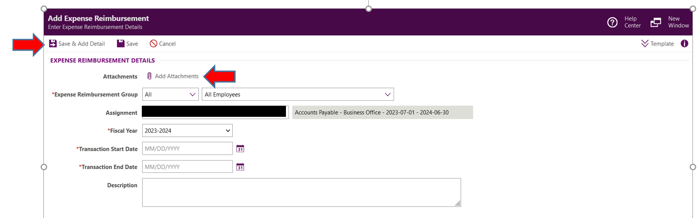

Fill in required information (*). Description must be detailed and include the purpose of the purchase. Fill in the amount to be reimbursed. If taxes were charged, deduct from total as taxes are not reimbursable. The account code must also be entered and will be denied without one. Click on Save & Submit.

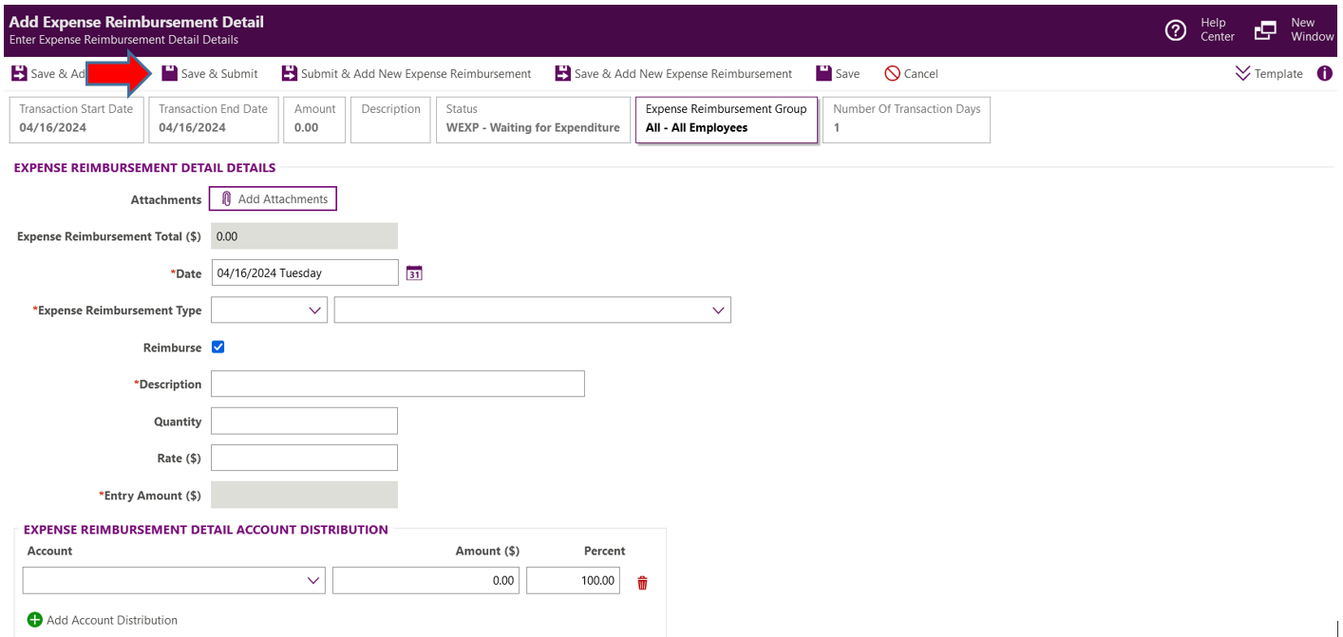

Once submitted, this will go to your office manager/supervisor for approval, then, on to the Accounts Payable department for final approval. Upon final approval, a check will be paid out in the next Accounts Payable check run.

**Employee Contracts**

Employees will now receive contracts and notices of assignment through their Skyward Employee Access portal. To view and accept your contract, go into Skyward Employee Access and click on the Contract Letters tile.

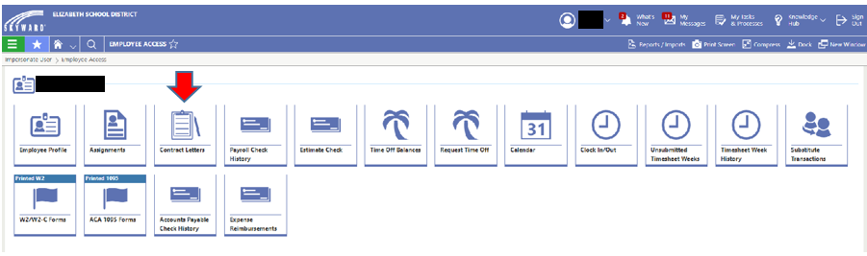

Open the contract letter.

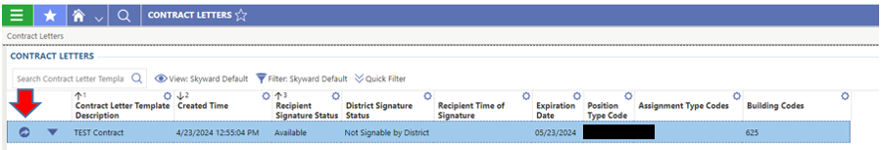

**Note:** You will receive a separate contract for each assignment. You must open and approve each one separately.

Confirm the information is correct. If incorrect, contact Human Resources. If correct, click Sign.

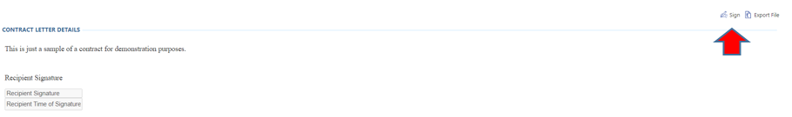

Click sign again.

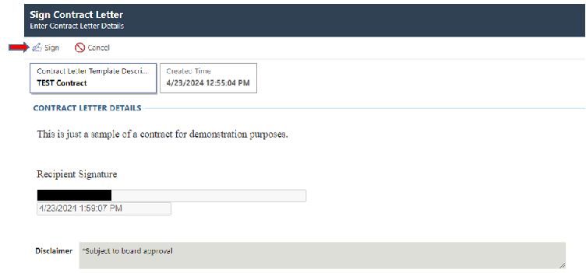

You have now completed signing your contract.

**Additional Skyward Resources**

**Skyward Support – Employee Access Training Link**

[**https://www.skyward.com/employeeaccess/qmlativ**](https://www.skyward.com/employeeaccess/qmlativ)

Please note: There are some wonderful training videos available on this site. We are still implementing portions of this system so some areas may not be applicable or available at this time. The main videos that may be of interest include:

* Check History
* Message Center
* Personalize Your Experience
* Power-Up: Downloading the App
* Power-Up: Using the App

The other videos will be of importance at a later date.